Environment and Protective Services Committee

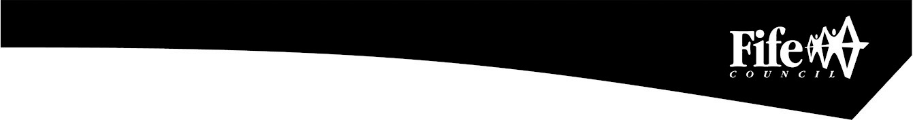

All Committee meetings were cancelled with effect from 23rd March, 2020 due to the COVID-19 emergency.

The recommendations in this report were approved by an Executive Director of the Council, acting under delegated authority in terms of paragraph 2.1.1 of the Council’s List of Officer Powers

Environment & Protective Services Committee

Approved by the Executive Director (Enterprise and Environment) – 7th July, 2020
Appointment to Partner Organisation – Fife Resource Solutions
Report by: Morag Ferguson, Head of Legal and Democratic Services
Wards Affected: All Wards
Purpose
The Committee is asked to consider a change of membership to the Board of Fife Resource Solutions following the resignation of Councillor Heer.
Recommendation(s)
The Committee is asked to appoint Councillor Dave Coleman in place of Councillor Andy Heer as one of Council’s representatives on the Board of Fife Resource Solutions.
Resource Implications
None.
Legal & Risk Implications
External organisations have their own governance structures and members should seek advice from Legal and Democratic Services on any concerns they have on membership of the organisations. In particular, members may be subject to other legislation such as the Companies Acts (directors’ responsibilities) and charity law.
Impact Assessment
An EqIA is not required because the report does not propose a change to existing policies and practices.
Consultation
The respective organisation has been consulted as appropriate.
1.0 Background
1.1 The appointment of members to the Board of Fife Resource Solutions normally falls under the remit of the Environment & Protective Services Committee.
1.2 However, due to the need for appointments to be made prior to the imminent meeting of the Board, Councillors David Barratt, Andy Heer and Jan Wincott were appointed by Fife Council on 15 June 2017 to the Board of Fife Resource Solutions.
- Current position
  - Councillor Heer has now resigned and the vacancy requires to be filled.
  - At a meeting of the Cross Party Leaders Group it was agreed that Councillor Dave Coleman be nominated to fill the vacancy.
3.0 Conclusion
3.1 Following the resignation of Councillor Heer the Committee is requested to appoint Councillor Coleman to fill this vacancy.

List of Appendices
None

Background Papers
The following background papers were relied on in the preparation of this report in terms of the Local Government (Scotland) Act, 1973:-
Appointments to Partner Organisations - Report to Council on 15 June, 2017

Report Contact
Elizabeth Mair
Committee Officer
Democratic Services
Fife House
Glenrothes

Telephone: 03451 55 55 55 + 442304
Email – elizabeth.mair@fife.gov.uk

